6.170 Laboratory in Software Engineering
Spring 2003

Final Project Gizmoball
Preliminary Design
4.16.03

Group: se042 gb@mit.edu
TA: Stefanie Tellex
Members: David Tsai
Eric Koi Tung
Ragu Vijaykumar
Ran Tao
REQUIREMENTS

Overview

The final project is to design, document, build, and test a program that plays Gizmoball. Gizmoball is a version of pinball, an arcade game in which the object is to keep a ball moving around in the game, without falling off the bottom of the playing area. The player controls a set of flippers that can bat at the ball as it falls. It is also possible to form machine layouts similar to complicated “Rube Goldberg” contraptions that are intended to be watched rather than played.

This implementation adds to the original specifications stated above by approaching it an entirely new way: 3D. The Gizmoball program relies on a full 3D platform, with cubical, spherical, and prism bumpers, absorbers, teleporters, flippers and balls in a 3D cubical playing field of 20 x 20 x 20 (fig. 1 & 2).

The user can choose among the following for Gizmoball::

- gizmos
- ball
- absorber
- bouncer
- leftflipper
- rightflipper
- fusion
- teleporter
- bumper
- breakablebouncer
- plug-ins (modes)
- pool
- arkanoid
- pinball
- tetris
- otherr

Gizmoball has a graphical user interface in which there are two modes, one to build and one to run each of the plug-ins. In the build mode, the user will create and modify the playing field by adding, moving, and deleting gizmos. The user will be able to delegate connections for actions between gizmos, as well as assign hotkeys for keyboard input. There is also the option to show gridlines and wire-frame modes while editing (fig. 3).

In the run mode, the user is able to interact with the game, or to watch it like a “Rube Goldberg.” Because of the 3D aspect of the game, the user will also be able to choose the camera placement in which to view the playing area: Perspective View, Front-Locked View, Side-Locked-View, and Top-Locked-View (fig. 3).
3D Game Field
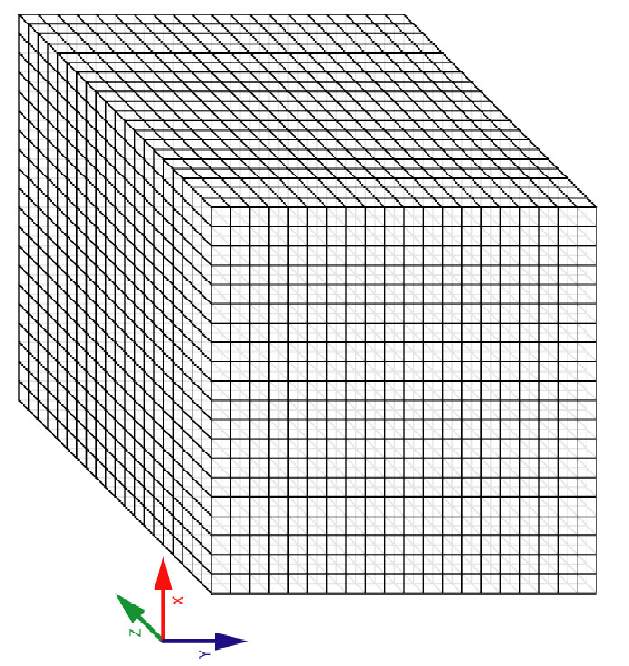
Fig. 1: Orientation of Playing Field

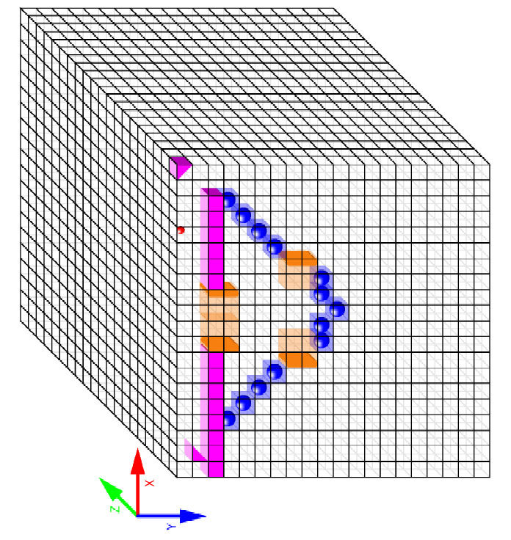
Fig. 2: Demo Use of Grid
GUI

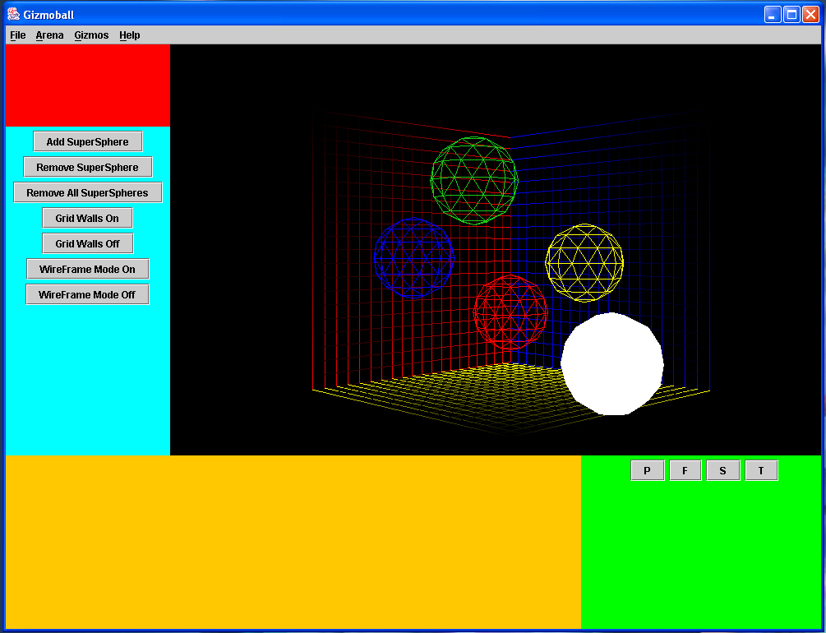
Fig. 3: GUI Game Board in Progress

Panels:
- Red = Function buttons (Play, etc.)
- Cyan = List of gizmos
- Orange = Properties of currently slected gizmo
- Light Green = Camera control

The P/F/T/S buttons on the light green section right now toggle the camera view to Perspective View (the one seen in the screenshot), Front-Locked View, Side-Locked-View, and Top-Locked-View.

GUI is locked (window not resizable) at 1000x750 resolution. This way it will be able to fit on a 1024x768 standard monitor resolution.

A gizmo will also "light up" when it is selected by the mouse as indicated by the white sphere

Another possible layout:

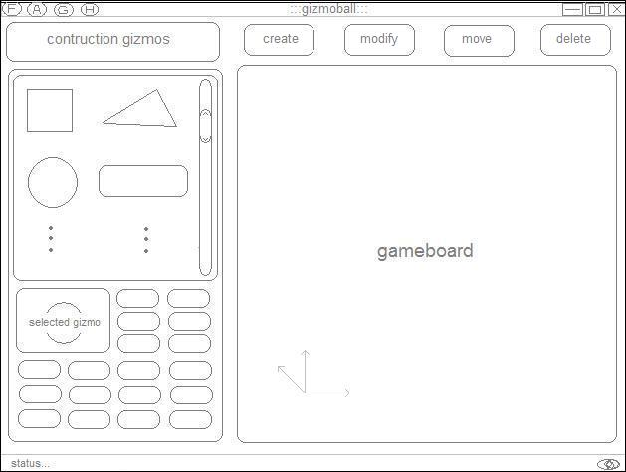
Fig. 4: Possible GUI Layout for edit mode

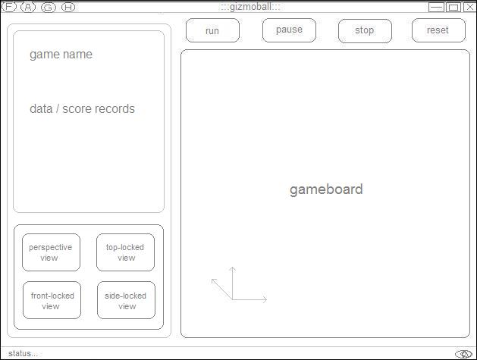
Fig. 5: Possible GUI Layout for play mode
Problem Object Model

[insert here]

DESIGN

Overview

Gizmoball consists of 5 main components:
- physics3D
- GUI
- engine
- plug-ins
- gizmos

Physics3d, GUI, and engine are all packages; plug-ins is a folder into which users can drop gizmo class files and mode description files.

The GUI consists of the main Gizmoball GUI, which has the main outer frame, MainFrame. The MainFrame adds a set a panels and the 3D arena, and sets up the menu in the window (fig. ##). The panels that are added are: CanvasPanel.java (this panel also holds the Canvas3D fig.##), FunctionsPanel.java, GizmoListPanel.java, GizmoPropertiesPanel.java, and CameraControlPanel.java. The GUI also draws the Gizmos when engine is finished with a time slice. In addition it also handles the UI and file loading/saving.

Physics3D handles time until collision and the reactions on the field given spheres, planes, lines, and/or points. It detects collisions and calculates the result of those collisions depending on the objects involved. The structure closely matches that of the provided physics 2D package. Geometry is called by the Engine to determine shortest time to collision.

Engine keeps track of Gizmos and handles the simulation with the progression of each time slice, at the same time updates the internal state of gizmos. The entire board is broken up into partition blocks which the engine can check to see whether a gizmo is contained within a certain block. Each block that contains gizmo(s) is kept track of in a map.

We have Gizmo and MobileGizmo interfaces which define how Gizmos will be written. Gizmos know things like where they are, how to give GUI information about how to draw them, and what to give engine to calculate collisions. Each Gizmo can be seen as a plug-ins themselves, and have properties that are not limited to: type, mass, density, friction, location, color, speed, mutability, mobility, etc…

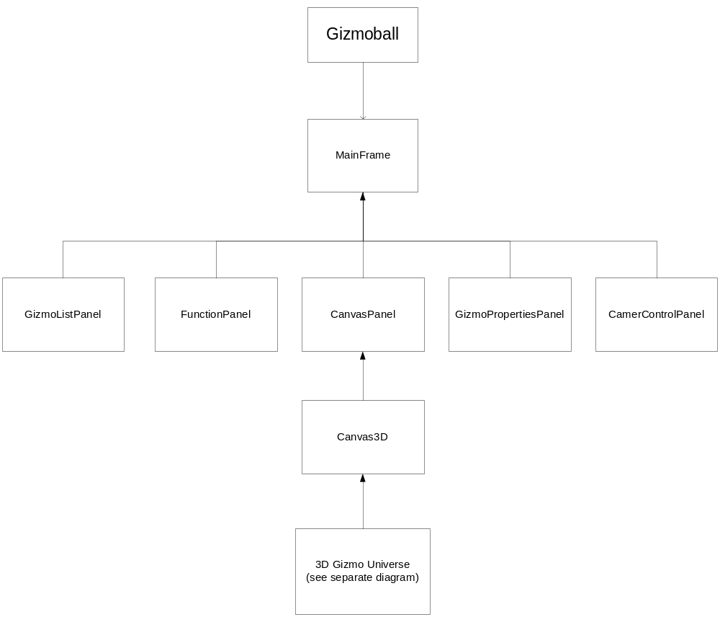

Fig. 7: GUI Object Model

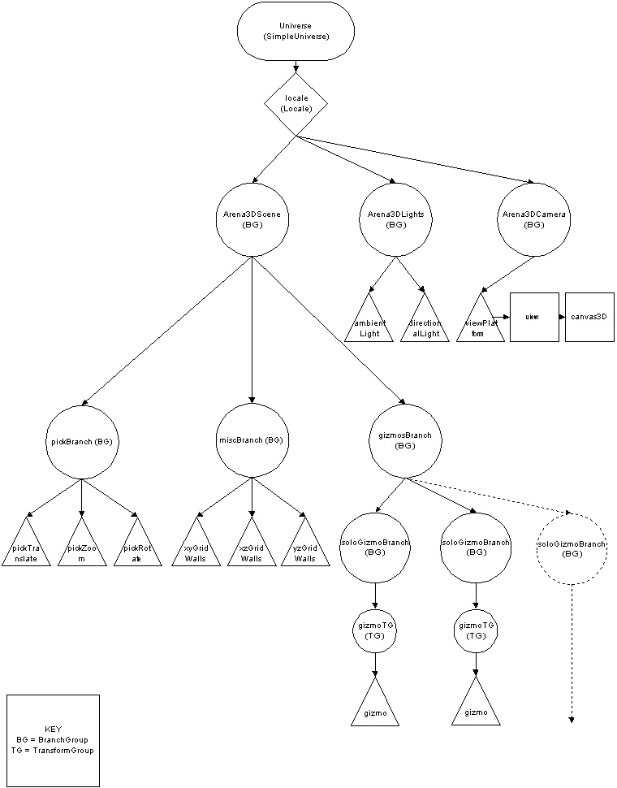

Fig. 8: 3D Gizmo Universe Object Model

The Physics Loop

- Handle any actions that have been queued up since the last cycle.
- Check for key presses (if true go to step 5)
- Check partition blocks that hold gizmos at the time, and determine if there is going to be any collision between this time slice and the next (detected collision). Update the positions of all mobile gizmos.
- Repeat step 1-3 until a collision is detected. If collision detected then update positions of gizmos to the point of collision.
- Check for triggers that are assigned to any of the gizmos that are colliding, and perform the action for that trigger if true.
- Calculate the resulting change in velocity/position for each gizmo
- Update the velocity and positions of all effected gizmos
- Repeat steps 1-7 through the duration of the time slice. Save the state of the arena in a queue.
- Extract the most recent entry in the queue and send to GUI to repaint the screen.
- Go back to step 1.

Runtime Structure

GUI classes:

MainFrame
AboutPanel
Arena3D
Arena3DCamera
Arena3DLights
Arena3DScene
BoundingBorder
ComeraControlPanel
CameraMount
CanvasPanel
DrawAxes
DrawGridWalls
FunctionsPanel
GizmoListPanel
GizmoPropertiesPanel
SuperSphere
/Picking
/Behaviors
/Highlight
Physics3D classes:

Geometry
Cylinder
PlaneSegment
LineSegment3D
Sphere

Backend Engine classes:

Engine
PartitionBlock

See fig. 11.

IMPLEMENTATIONS:

GUI: MainFrame
/**
* MainFrame is the main outer frame of the Gizmoball GUI.
**/
// FIELDS
Container contentPane = this.getContentPane();
JMenuBar menuBar;
JToolBar toolBar;
public static Arena3D a3D;
public static Canvas3D canvas3D;

/**
* @effects Sets up the window.
**/
public MainFrame();

/**
* @effects Creates the GUI's menu bar.
**/
public JMenuBar createMenuBar();

/**
* @effects Handles all user-interactions with this.
**/
public void actionPerformed(ActionEvent evt);

Physics Engine: Geometry
See fig. 9 & 10

// Spin is not currently accounted for; however, the use of Transform3D allows
// it to be added to physics without changing any other class.
// This will not be done by me during 6.170.

private static final double pipTolerance = 0.0001; // point-in-Polygon tolerance
protected static boolean showDebugInfo = false;

/**
* Accounts for the effects of inelastic collisions given the initial transform
* and change in transform of the collision assuming elasticity and returns the
* resulting velocity after an inelastic collision.
**/
private static Transform3D applyReflectionCoeff(Transform3D inOutTransform, Transform3D deltaTransform, double rCoeff);

/**
* Computes the new velocity of a ball after bouncing (reflecting)
* off of a Sphere.
**/
public static Transform3D reflectBallFromSphere(Sphere ball, Sphere sph, Transform3D ballVelocity, double sphCOR) ;

/**
* Computes the new velocity of a ball after bouncing (reflecting)
* off of a Sphere.
**/
public static Transform3D reflectBallFromSphere(Sphere ball, Sphere sph, Transform3D ballVelocity);

/**
* Computes the new velocity of a ball after bouncing (reflecting)
* off a Cylinder.
**/
public static Transform3D reflectBallFromCylinder(Sphere ball, Cylinder cyl, Transform3D ballVelocity, double cylCOR);

/**
* Computes the new velocity of a ball after bouncing (reflecting)
* off a Cylinder.
public static Transform3D reflectBallFromCylinder(Sphere ball, Cylinder cyl, Transform3D ballVelocity);

/**
* Computes the new velocity of a ball after bouncing (reflecting)
* off a wall.
**/
public static Transform3D reflectBallFromPlane(PlaneSegment pseg, Transform3D ballVelocity, double planeCOR);

/**
* Computes the new velocity of a ball after bouncing (reflecting)
* off a wall.
**/
public static Transform3D reflectBallFromPlane(PlaneSegment pseg, Transform3D velocity);

/*compute the timeuntil for all types of collisions*/
.
.
.

Backend: Engine

/**
*Engine - this is the main class that will be reacting with the gizmos
**/
// FIELDS
// Checks
private boolean setup;
// Gizmo Information
private Collection listOfGizmos;
private Collection ballList;
private Collection staticGizmos;
private Collection rotateGizmos;
private Collection mobileGizmos;

// Dimensions of the playing field
private final Point3d origin;
private final Point3d upperCorner;

// How many paritition blocks to divide the space into
private static final int PARTITION_X = 20;
private static final int PARTITION_Y = 20;
private static final int PARTITION_Z = 20;

// Abstraction of playing field
private Map playingField;
/**
* Creates an engine for the following list of gizmos
* @param listOfGizmos - list of Gizmo type objects
*/
private Engine (Collection listOfGizmos, Point3d origin,Point3d upperCorner);

/**
* Returns a new instance of the engine used to process the playing field
*/
public static Engine buildEngine(Collection listOfGizmos,Point3d origin,Point3d upperCorner);

// Mutators

/**
* Adds the following gizmo to the list of gizmos to be processed
* @param gizmo - gizmo to be added to the engine
*/
public void addGizmo(Gizmo gizmo);

/**
* Deletes the following gizmo from the list of gizmos
* @param gizmo - gizmo to be deleted
*/
public void deleteGizmo(Gizmo gizmo);

/**
* Sets the Engine up to begin detection
* Only need to call this once or each time after a new gizmo is added or deleted
* from runtime, not build time
*/
public void setup() ;

/**
* Will determine everything that happens in the gizmo arena within the next timeslice
* @param timeSlice - amount of time that will pass before gizmos are to be redrawn
* @modifies gizmos in list of gizmos
* @throws IllegalArgumentException - if the amount of time is less than or equal to zero
*/
public void update(double timeSlice);

Module Structure:

See fig.12.

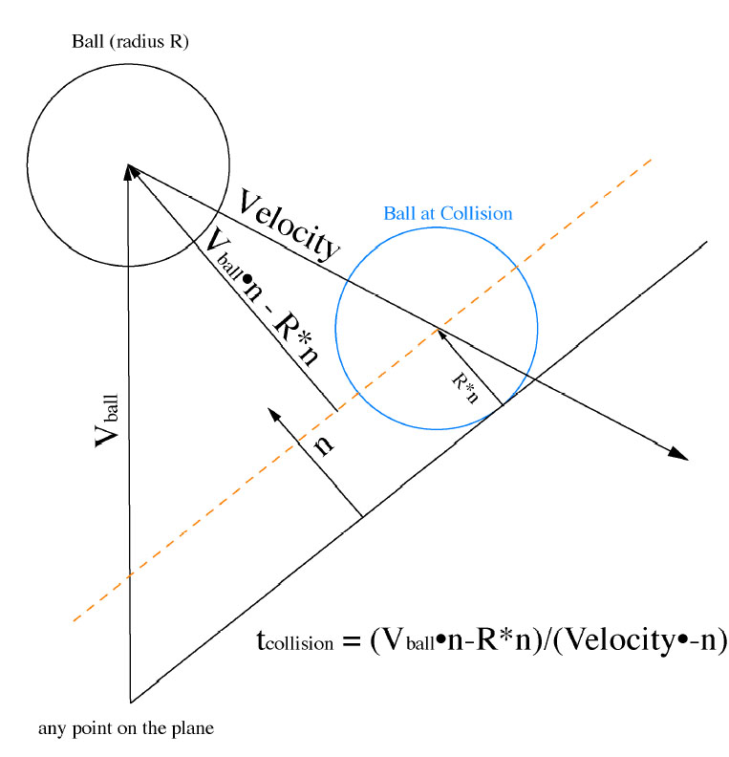
Fig. 9: Moving Ball / Non-moving Plane Collision

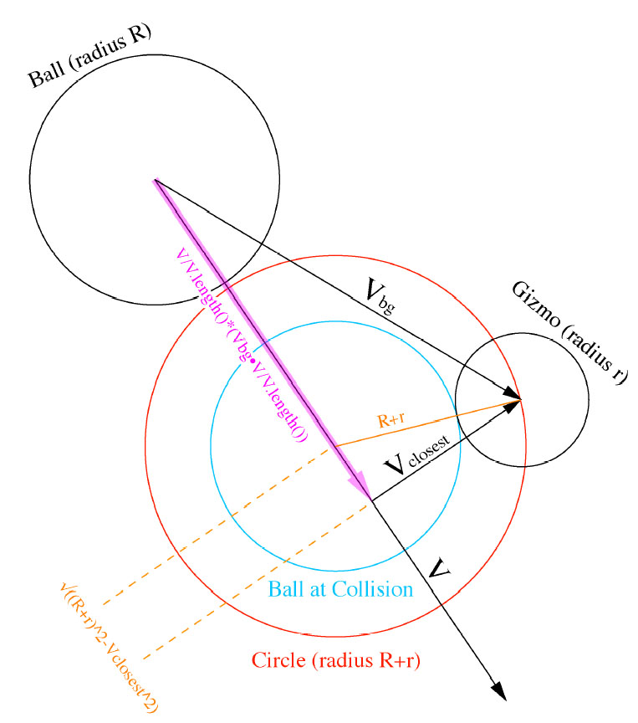
Fig. 10: Moving Ball / Non-moving Gizmo Collision

CODE OBJECT MODEL

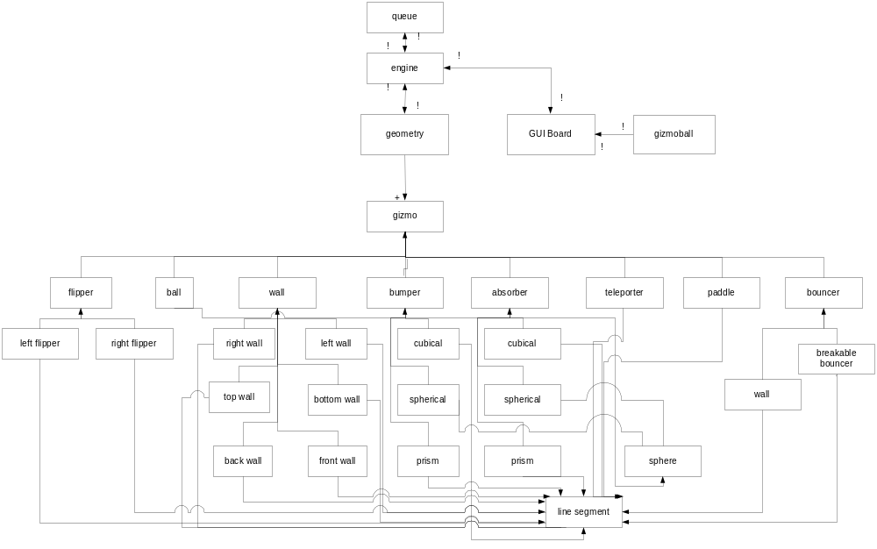

Fig. 11: Code Object Model

MODULE DEPENDENCY DIAGRAM

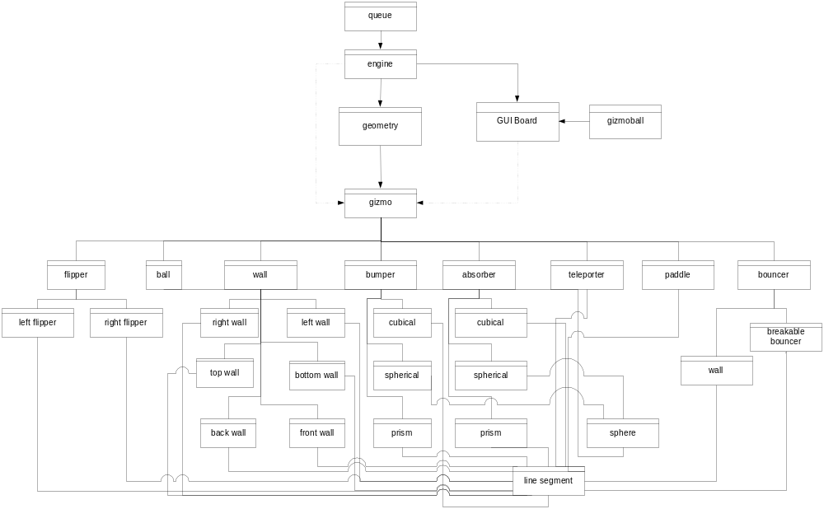

Fig. 12: Module Dependency Diagram
PROJECT PLAN

Milestones | Who | Date
- Preliminary GUI interface design decided upon and implemented  - Learn how to integrate the Java3D API with Swing.  - Research the Java3D API. This includes:  i) Designing and implementing a scene branch.  ii) Learning the different intricacies of the API (mouse behaviors, mouse picking, setting up cameras, setting up lights, how to manipulate 3D objects, etc.)  - Be able to add and delete gizmos, or at least simple 3D shapes (gizmo placeholders) onto the playing arena.  - Be able to interface with the backend (i.e. have a functional "play" feature that is able to send and retrieve information from the backend). | Group | 4.20
Get ball:rotating object collision detection/reaction methods written and tested | Eric | 4.20
Finish engine that handles gizmos and physics | Ragu | “
Optimize for speed | Eric | 4.27
Develop method invocation module | Ragu | “
Program interface of buttons for GUI | Ran | “
Preliminary Release | Group | 4.29
Debugging and Testing | Group
Implementation and Testing | Group | 5.13
User Interface and Quality of Play | Group | “
Final Report | Group | “

